**Part1**: Set up working environment

1. MySQL version：

Password: 123(if needed)

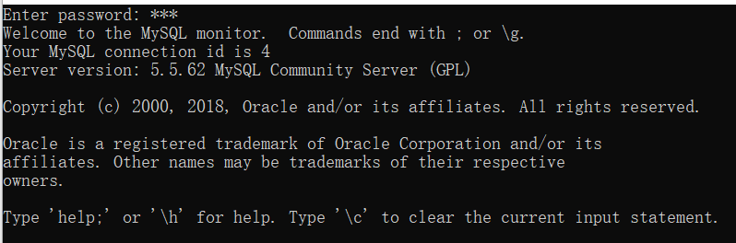

1. Development tools:

SQLyog Ultimate – MySQL GUI v12.09(64 bit)

(c) 2001-2013 Webyog Inc.

<http://www.webyog.com>

1. Setting information(MySQL and SQLyog)

References: <https://zhuanlan.zhihu.com/p/24959854>

1. Import data into SQLyog(or other tools you’re familiar)
2. Create a database(Ctrl + D) named “ccvg”
3. Click on “ccvg” database, and then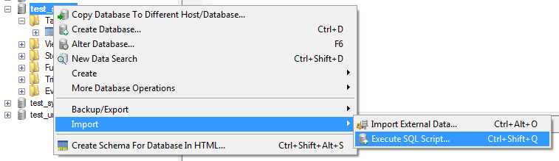
4. Select “ccvg.sql” to import data
5. Done

There would be some bugs during this operation, try to fix according to <https://blog.csdn.net/u013067184/article/details/48007393>

**Part2**: Data origin

1. Original datasets(.csv files): <https://d-scholarship.pitt.edu/37663/>

**Part3**: Database design details

1. ER Diagram: 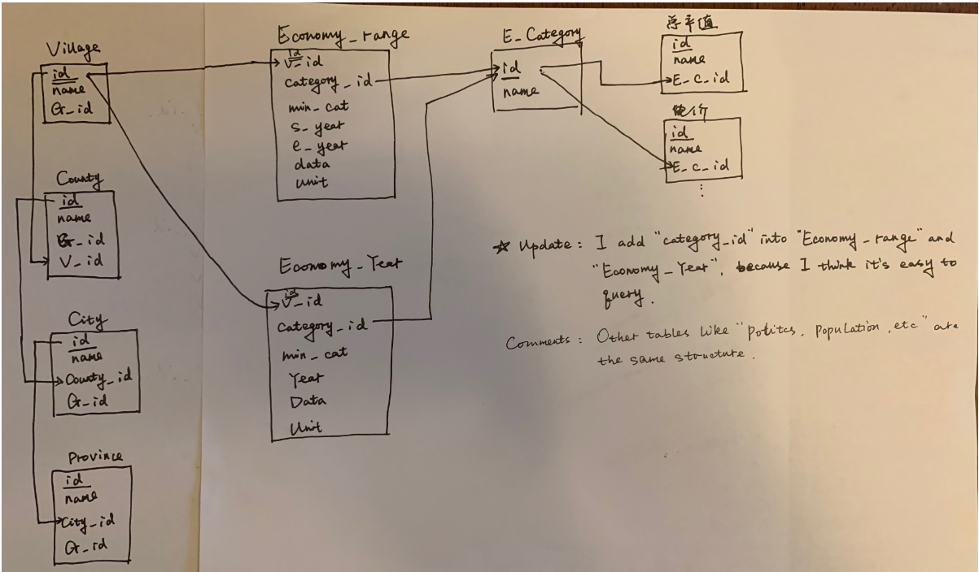
2. All “updated” tables are the needed but I kept original tables so that you can see the original structures to improve.
3. Village Information: Split into “province”, “city”, “county”, “province-village”, “city-village”, “county-village”, “v_updated”, “village_updated”, “village_information_area_and_distance”, “village_information_long_and_lati”, “village_county_city_province”.
4. Other simple tables(Natural Environment, Natural Disasters, Last Name, Year of First Availability or Purchase): updated or keep the same
5. Remaining tables(Ethnic Groups, Population, Military, Economy, Family Planning and Education): each part has three tables, “yearly_updated”, “range_updated” and “category”
6. Something to improve(optional):
7. Make some changes to query it more quickly
8. TBD

**Part4**: Interface development

1. Use IntelliJ IDEA (<https://www.jetbrains.com/idea/download/#section=windows>) to develop. One year free for student account.
2. Import Bootstrap (<https://v3.bootcss.com/getting-started/#download>) into project.
3. Website reference: <http://ghdx.healthdata.org/gbd-results-tool>
4. What have done: Develop different pages according to basic sociological questions (backup/ccvg-april8Report-v3.docx). Home page is for “Retrieve all information/data for any of singular village”, “Compare information/data between two villages” and “Retrieve information/data for all villages within a county, city or province”. The layout can be changed to button or other styles.
5. To do list:
6. Develop all sub-pages based on one area like “Politics”, “Population” and so on.
7. Make it more user-friendly(<https://v3.bootcss.com/components/>)
8. Connect with database
9. Add visualization, like Tableau(Pitt has authorization to use)
10. Add function to download the result